PANDIT DEENDAYAL ENERGY UNIVERSITY
SCHOOL OF TECHNOLOGY


Course: Machine Learning Lab
Course Code: 20CP401P
LAB MANUAL

Submitted To: | Submitted By:
Dr. Debabrata Swain | Mangrolia Dwarkesh Ghanshyambhai
 | 23BCP263

Experiment 1: Data visualization

Aim: To explore and analyze various data visualization tools used for representing and understanding complex datasets.

Source code:
import pandas as pd
import matplotlib.pyplot as plt

# Load dataset
df = pd.read_csv("brain_stroke.csv")

# Display first five records
df.head()

print("Shape of dataset:", df.shape)
print("\nColumns:")
print(df.columns)

print("\nDataset Information:")
df.info()

stroke_counts = df["stroke"].value_counts().sort_index()

plt.figure(figsize=(7, 5))

plt.bar(
["No Stroke", "Stroke"],
stroke_counts.values
)

plt.xlabel("Stroke Status")
plt.ylabel("Number of People")
plt.title("Number of Stroke and Non-Stroke Cases")

plt.show()

age_no_stroke = df[df["stroke"] == 0]["age"]
age_stroke = df[df["stroke"] == 1]["age"]

plt.figure(figsize=(7, 5))

plt.boxplot(
[age_no_stroke, age_stroke],
labels=["No Stroke", "Stroke"]
)

plt.xlabel("Stroke Status")
plt.ylabel("Age")
plt.title("Age Distribution by Stroke Status")

plt.show()

numeric_df = df.select_dtypes(include="number")

correlation = numeric_df.corr()

plt.figure(figsize=(9, 7))

plt.imshow(correlation, cmap="coolwarm", aspect="auto")

plt.colorbar(label="Correlation")

plt.xticks(
range(len(correlation.columns)),
correlation.columns,
rotation=45,
ha="right"
)

plt.yticks(
range(len(correlation.columns)),
correlation.columns
)

plt.title("Correlation Heatmap - Matplotlib")

plt.show()

import pandas as pd
import matplotlib.pyplot as plt
import seaborn as sns

# Load dataset
df = pd.read_csv("brain_stroke.csv")

df.head()

print("Shape of dataset:", df.shape)
print("\nMissing Values:")
print(df.isnull().sum())

plt.figure(figsize=(7, 5))

sns.countplot(
data=df,
x="stroke"
)

plt.xlabel("Stroke Status")
plt.ylabel("Number of People")
plt.title("Number of Stroke and Non-Stroke Cases")

plt.show()

plt.figure(figsize=(7, 5))

sns.countplot(
data=df,
x="stroke"
)

plt.xlabel("Stroke Status")
plt.ylabel("Number of People")
plt.title("Number of Stroke and Non-Stroke Cases")

plt.show()

plt.figure(figsize=(7, 5))

sns.boxplot(
data=df,
x="stroke",
y="age"
)

plt.xlabel("Stroke Status")
plt.ylabel("Age")
plt.title("Age Distribution by Stroke Status")

plt.show()

numeric_df = df.select_dtypes(include="number")

correlation = numeric_df.corr()

plt.figure(figsize=(10, 7))

sns.heatmap(
correlation,
annot=True,
cmap="coolwarm",
fmt=".2f"
)

plt.title("Correlation Heatmap - Seaborn")

plt.show()

import pandas as pd
import plotly.express as px

df = pd.read_csv("brain_stroke.csv")

df.head()

stroke_counts = (
df["stroke"]
.value_counts()
.reset_index()
)

stroke_counts.columns = ["stroke", "count"]

stroke_counts["stroke"] = stroke_counts["stroke"].map({
0: "No Stroke",
1: "Stroke"
})

fig = px.bar(
stroke_counts,
x="stroke",
y="count",
title="Number of Stroke and Non-Stroke Cases",
labels={
"stroke": "Stroke Status",
"count": "Number of People"
}
)

stroke_counts = (
df["stroke"]
.value_counts()
.reset_index()
)

stroke_counts.columns = ["stroke", "count"]

stroke_counts["stroke"] = stroke_counts["stroke"].map({
0: "No Stroke",
1: "Stroke"
})

fig = px.bar(
stroke_counts,
x="stroke",
y="count",
title="Number of Stroke and Non-Stroke Cases",
labels={
"stroke": "Stroke Status",
"count": "Number of People"
}
)

fig.show()

fig = px.box(
df,
x="stroke",
y="age",
points="outliers",
title="Age Distribution by Stroke Status",
labels={
"stroke": "Stroke Status",
"age": "Age"
}
)

fig.show()

numeric_df = df.select_dtypes(include="number")

correlation = numeric_df.corr()

fig = px.imshow(
correlation,
text_auto=".2f",
color_continuous_scale="RdBu_r",
title="Correlation Heatmap - Plotly"
)

fig.show()

import pandas as pd
from plotnine import *

# Load dataset
df = pd.read_csv("brain_stroke.csv")

# Display first 5 rows
df.head()

print("Shape of dataset:", df.shape)

print("\nColumns:")
print(df.columns.tolist())

print("\nMissing values:")
print(df.isnull().sum())

# Convert stroke values into meaningful labels
df["stroke_status"] = df["stroke"].map({
0: "No Stroke",
1: "Stroke"
})

df["stroke_status"] = pd.Categorical(
df["stroke_status"],
categories=["No Stroke", "Stroke"]
)

(
ggplot(df, aes(x="stroke_status"))
+ geom_bar()
+ labs(
title="Number of Stroke and Non-Stroke Cases",
x="Stroke Status",
y="Number of People"
)
+ theme_minimal()
)

(
ggplot(df, aes(x="stroke_status", y="age"))
+ geom_boxplot()
+ labs(
title="Age Distribution by Stroke Status",
x="Stroke Status",
y="Age"
)
+ theme_minimal()
)

correlation_long = (
correlation
.reset_index()
.melt(id_vars="index")
)

correlation_long.columns = ["variable1", "variable2", "correlation"]

correlation_long.head()

(
ggplot(
correlation_long,
aes(
x="variable1",
y="variable2",
fill="correlation"
)
)
+ geom_tile()
+ scale_fill_gradient2(
low="blue",
mid="white",
high="red",
midpoint=0
)
+ labs(
title="Correlation Heatmap - Plotnine",
x="Variables",
y="Variables",
fill="Correlation"
)
+ theme_minimal()
+ theme(
axis_text_x=element_text(rotation=45, hjust=1)
)
)

Output:
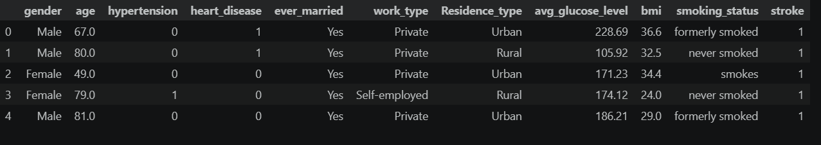
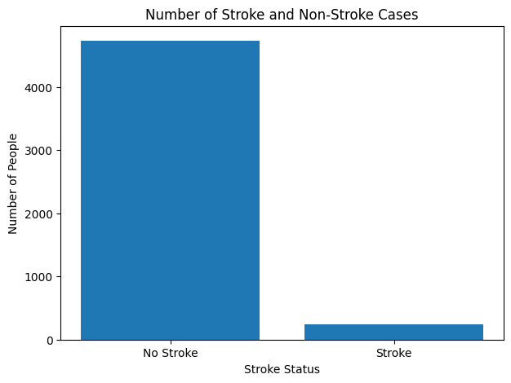
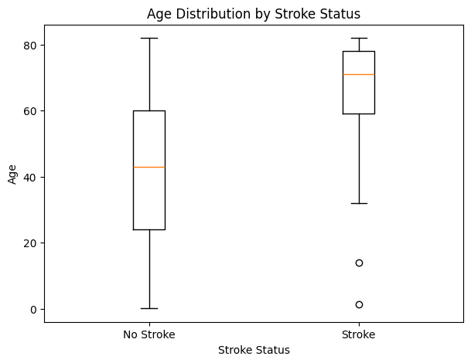
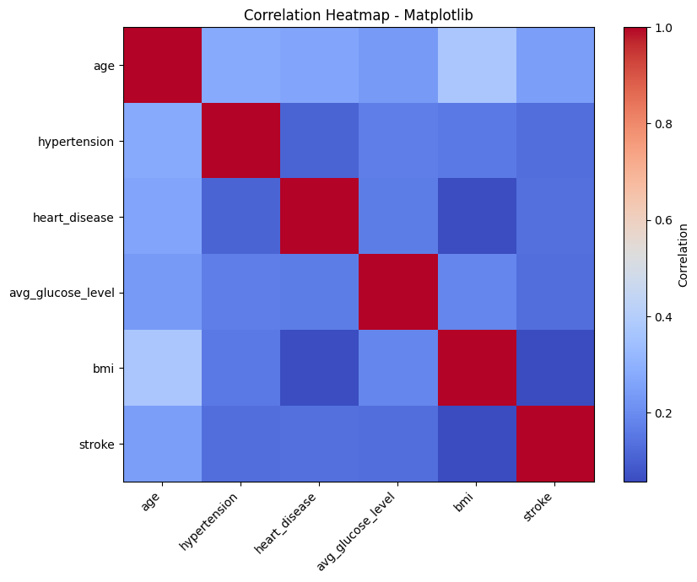
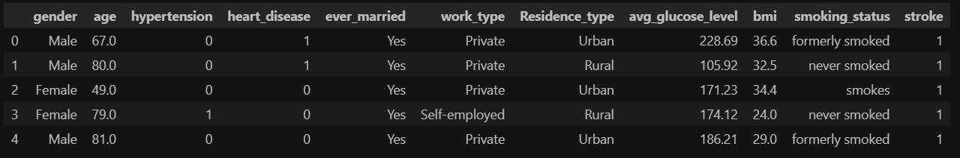
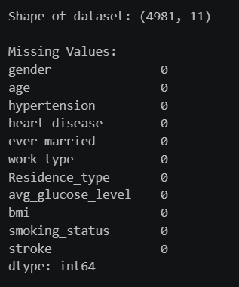
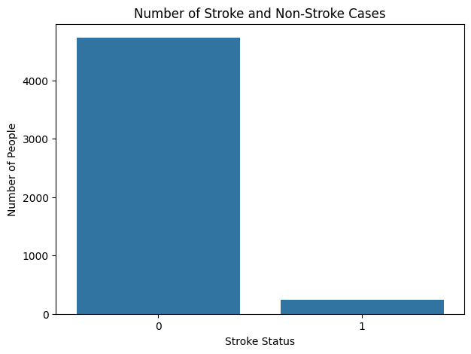
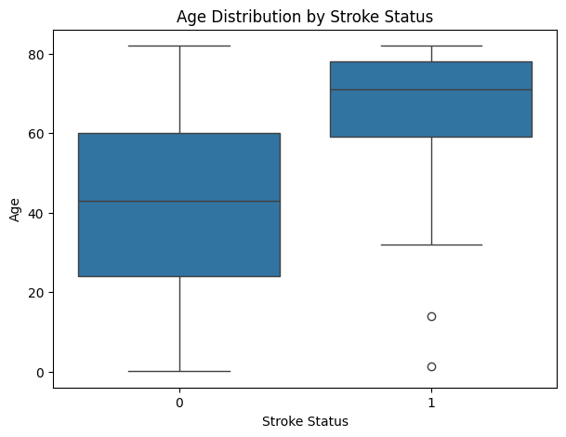
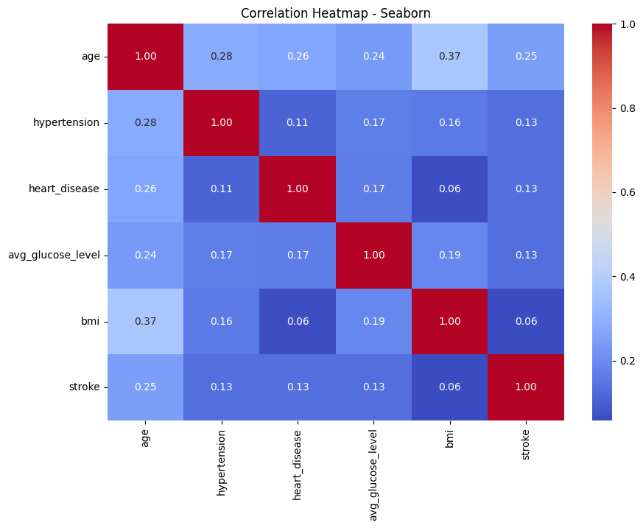
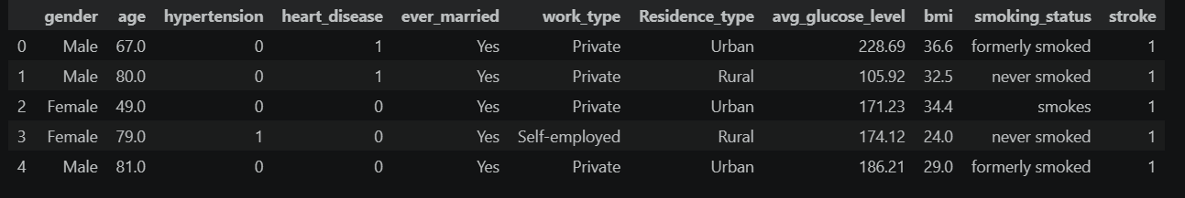
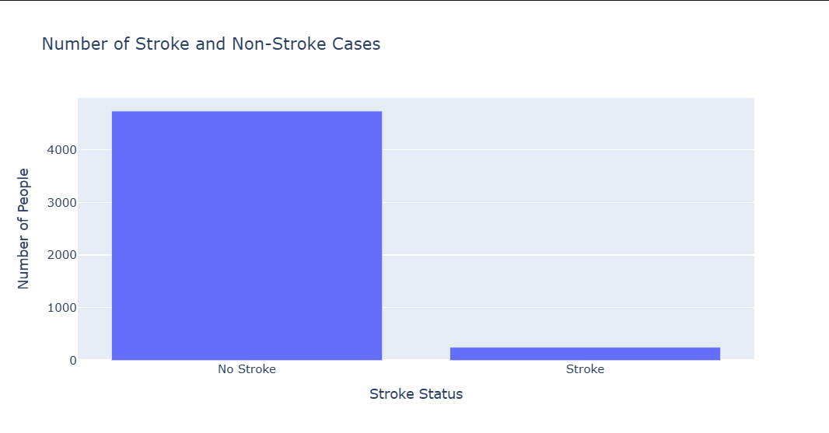
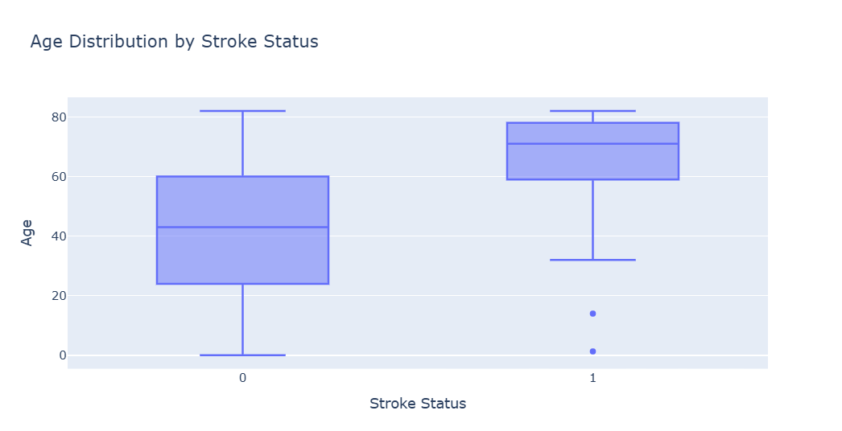
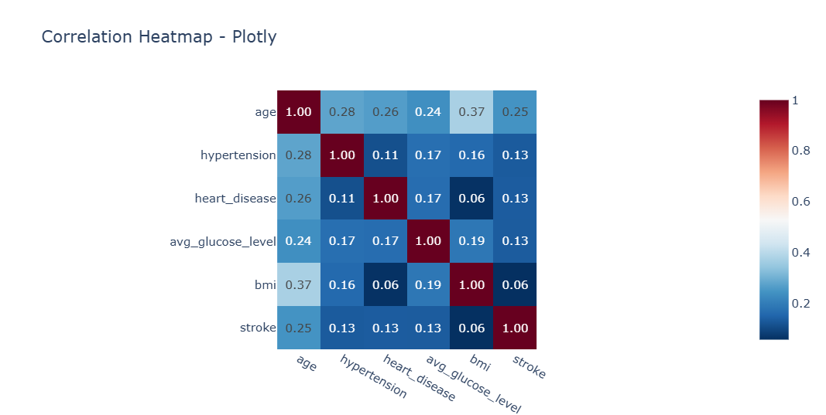
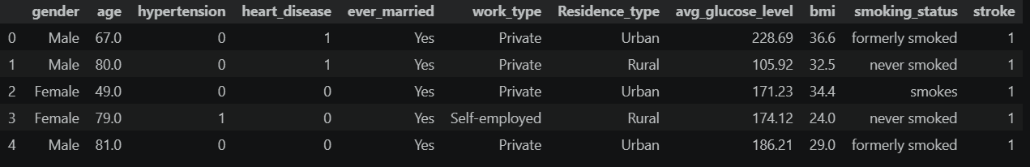
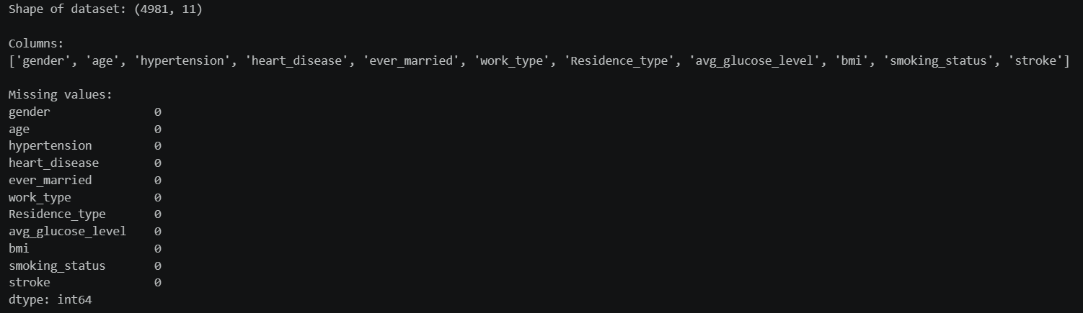
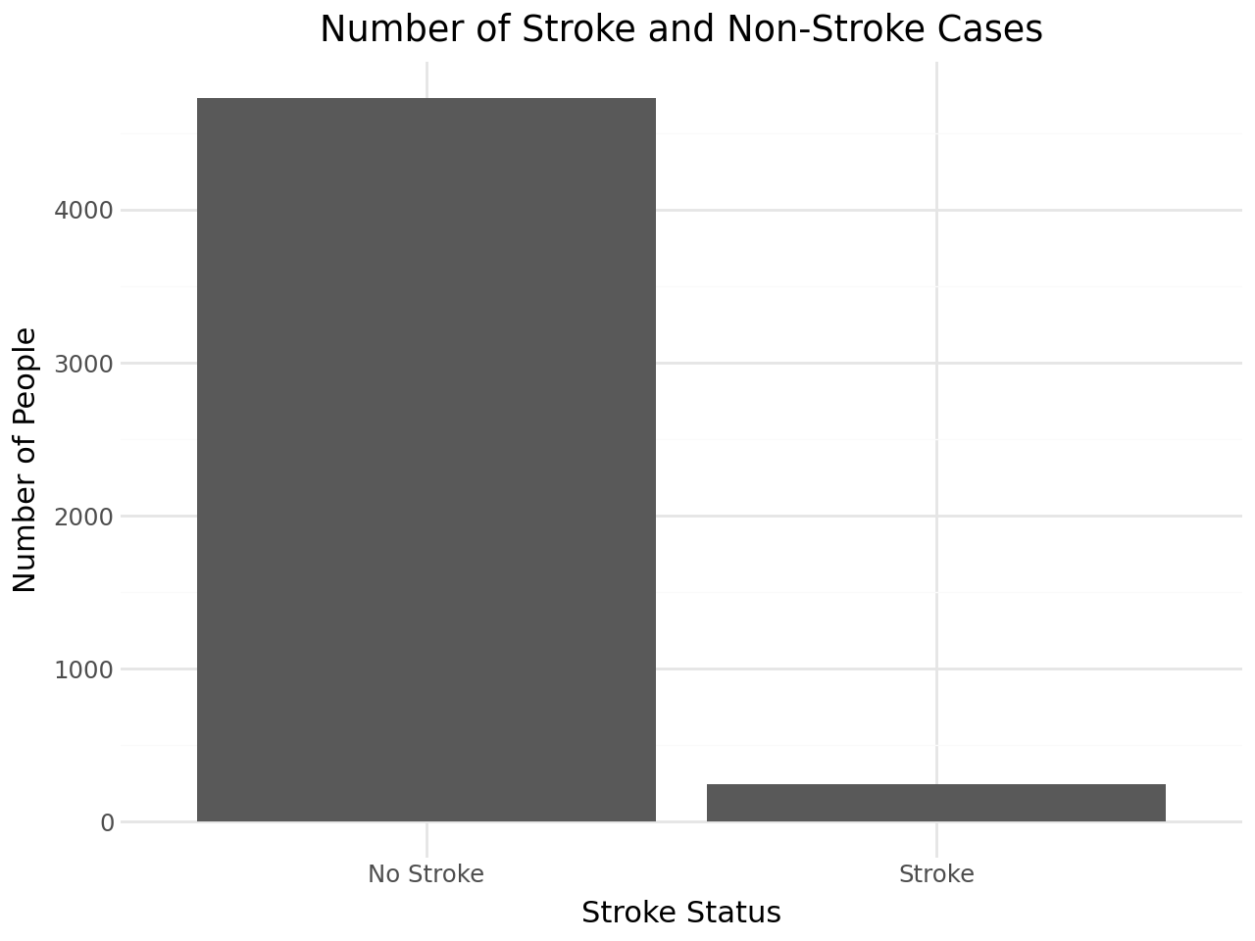
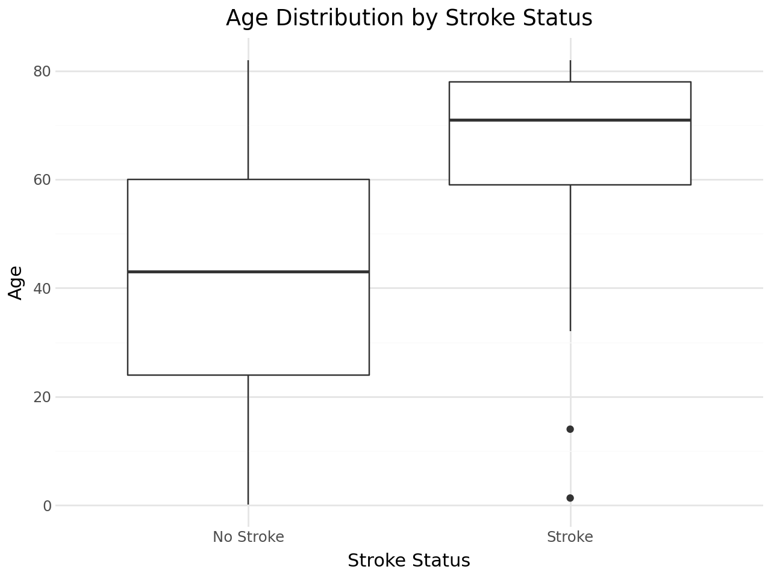
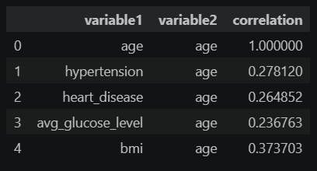
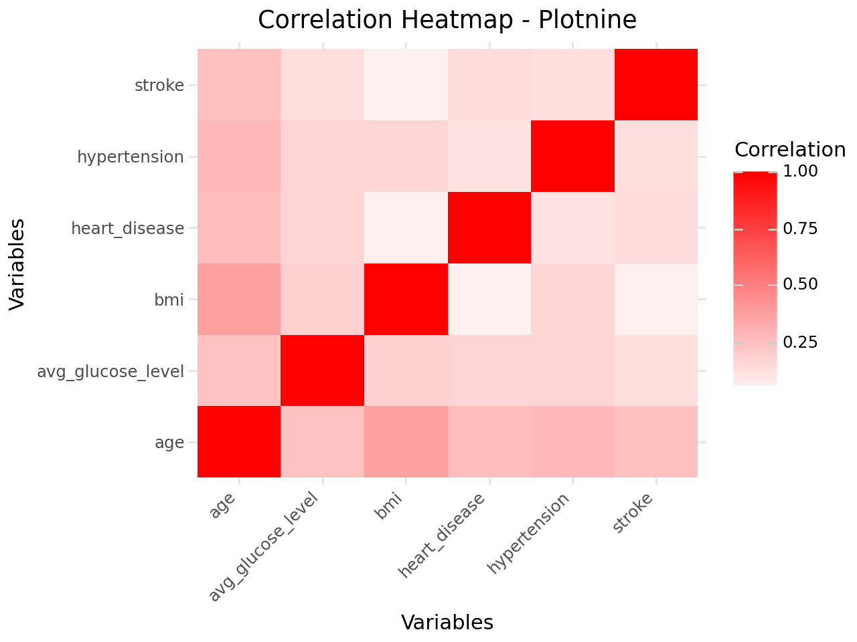

Brief overview of each tool:

1. Matplotlib
- Matplotlib is a widely used Python library for creating data visualizations.
- It provides a high level of control over the appearance and structure of graphs.
- It supports bar charts, line graphs, scatter plots, histograms, box plots, heatmaps, and many other visualizations.
- It works well with NumPy and Pandas for numerical and tabular data analysis.
- Users can customize titles, labels, axes, legends, markers, and figure sizes.
- It is mainly used for creating static and publication-quality visualizations.
- Matplotlib is particularly useful in scientific research, academic projects, and data analysis.
- Its main advantage is its flexibility, although creating complex graphs may require more code.

2. Seaborn
- Seaborn is a Python data visualization library built on top of Matplotlib.
- It is designed primarily for statistical data visualization and exploratory data analysis.
- It provides simple methods for creating attractive and informative graphs.
- It supports bar plots, box plots, violin plots, scatter plots, histograms, regression plots, and heatmaps.
- Seaborn works efficiently with Pandas DataFrames.
- It provides useful statistical features such as showing distributions and relationships between variables.
- It offers better default styling and color palettes than basic Matplotlib.
- It is particularly useful when analyzing patterns, correlations, distributions, and relationships in datasets.

3. Plotly
- Plotly is a Python visualization library mainly known for creating interactive visualizations.
- It supports bar charts, line graphs, scatter plots, box plots, heatmaps, maps, and 3D visualizations.
- Users can interact with graphs through hovering, zooming, panning, and selecting data.
- Plotly works well with Pandas, NumPy, and other Python data-analysis libraries.
- It is suitable for creating interactive dashboards and web-based data visualizations.
- It provides useful tooltips that allow users to examine individual data points.
- Plotly is commonly used for business analytics, scientific analysis, and interactive reporting.
- Its main advantage is interactivity, while complex visualizations may require more resources and configuration.

4. Plotnine
- Plotnine is a Python visualization library based on the Grammar of Graphics approach.
- It is inspired by the popular ggplot2 library from R.
- It allows users to construct visualizations by combining data, aesthetic mappings, layers, and graphical elements.
- It supports bar charts, box plots, scatter plots, line graphs, histograms, and heatmaps.
- Plotnine integrates well with Pandas DataFrames.
- It provides a consistent and structured approach for creating different types of visualizations.
- It is useful for statistical analysis, exploratory data analysis, and creating reproducible graphs.
- Plotnine is particularly suitable for Python users who prefer the structured plotting style of ggplot2.

Applications:
1. Matplotlib – Practical Use Case
A university can use Matplotlib to analyze students' academic performance. For example, it can create bar graphs to compare average marks across subjects, box plots to identify variations in marks, and heatmaps to study correlations between different subjects. It is particularly useful for generating static graphs for academic reports and presentations.

2. Seaborn – Practical Use Case
A healthcare organization can use Seaborn to analyze patient health data. For example, it can visualize the relationship between age, BMI, glucose level, and stroke occurrence using box plots, bar plots, and heatmaps. It is particularly useful for exploratory and statistical analysis, where identifying patterns and relationships in healthcare data is important.

3. Plotly – Practical Use Case
A hospital can use Plotly to develop an interactive healthcare dashboard. Users could hover over graphs, zoom into specific age groups, and explore stroke cases based on factors such as age, gender, BMI, and glucose level. Plotly is particularly useful when users need to interactively explore large datasets and discover patterns.

4. Plotnine – Practical Use Case
A data analyst can use Plotnine to perform exploratory analysis of a healthcare dataset such as the brain-stroke dataset. They can create bar graphs to compare stroke cases, box plots to analyze age distributions, and heatmaps to examine correlations between numerical variables. Plotnine is particularly useful when structured, reproducible statistical visualizations are required.

Strengths and weaknesses:

1. Matplotlib
Strengths:
- Highly customizable, allowing detailed control over graphs, axes, labels, and styles.
- Supports a wide variety of visualization types and integrates well with NumPy and Pandas.
Weaknesses:
- Complex visualizations can require a large amount of code.
- Provides limited interactivity compared with Plotly.

2. Seaborn
Strengths:
- Makes statistical visualizations such as box plots and heatmaps easy to create.
- Provides attractive default styles and integrates naturally with Pandas DataFrames.
Weaknesses:
- Offers less low-level customization than Matplotlib.
- Has limited support for interactive visualizations.

3. Plotly
Strengths:
- Provides highly interactive graphs with features such as zooming, hovering, and filtering.
- Supports a wide range of visualizations, including 3D charts and interactive dashboards.
Weaknesses:
- Complex interactive visualizations can require more resources and configuration.
- It can be less convenient than Seaborn for simple statistical visualizations.

4. Plotnine
Strengths:
- Uses the structured Grammar of Graphics approach, making complex visualizations easier to organize.
- Integrates well with Pandas and is useful for creating reproducible statistical visualizations.
Weaknesses:
- Has limited built-in interactivity compared with Plotly.
- Can have a steeper learning curve for users unfamiliar with the Grammar of Graphics approach.

Conclusion
Matplotlib is best suited for academic and scientific visualizations, while Seaborn is ideal for statistical analysis and exploratory data analysis. Plotly is preferable for interactive charts and dashboards, whereas Plotnine is useful for structured and reproducible statistical visualizations. The choice of tool depends on the type of data, level of interactivity, and purpose of the visualization. Overall, all four tools are effective, but each is better suited to different data visualization requirements.

